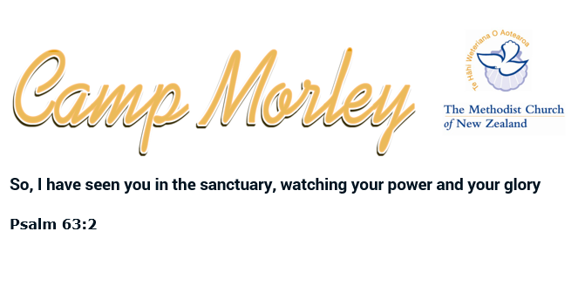
Terms and Conditions
Camp Morley is a very special place of character, as well the result of clever thinking by past elders of the Methodist Church community and many volunteers freely investing thousands of hours to develop the site to where it is today. Camp Morley is modern, provides a safe and practical Unit layout, Community Hall facilities and landscaped green spaces that are very special. The terms and conditions reflect the need to honour and protect the Camp for the continued enjoyment of groups and families for many years to come.
Booking and pre-arrival
- When enquiring to stay, you will then receive a Quote to which deposit and settlement details will be provided. Only after the quoted deposit is received will this become a secured booking of the Camp facility.
- It is the responsibility of the group / family leader to read and communicate the Health and Safety information ( located on the lower Homepage linked as a downloadable .doc ) to group participants.
- The group or family leader is required to inform Camp Morley of any increase or decrease to the group pax numbers as the arrival dates get closer. Also, for any special needs or requirements of individual guests or access to additional buildings, temporary structures or activity items and events requiring consideration.
- Communicate by email or phone any special arrival access or requirements.
- Normal occupancy is: 4pm arrival on booked day and departure before 2pm on the exit day.
- Booking cancellation policy:
* IF your deposit paid confirmed booking is cancelled + 60 days before arrival date: full refund
* IF your deposit paid confirmed booking is cancelled < 60 days before arrival date: Deposit forfeited.
* If your deposit and settlement ( usually paid 2 weeks prior ) is cancelled: Deposit and Settlement is forfeited.
* IF, Camp Morley cancels your deposit paid booking, due to unforeseen reasons: full refund
* Camp Morley reserve the right to consider any of these circumstances on a case by case basis.
Welcoming arrival and set-up
- The Camp Manager, will meet your group or family leadership and explain any special new information required and to hand over keys to Units, Community Hall or other Facilities ( if required ).
- If you find any irregularities with Camp items, breakages, items not working properly: report these to the Camp Manager straight away.

In-Camp duty of care
- Ensure the group guests are made aware of these considerations:
- The Camp Managers ( Duncan Evans ) role is an onsite residency role that is partime: know that if not onsite: contact can be made on 027 232 1738
- No smoking in any buildings at the Camp site.
- Explain that fire alarms are located in all Units, Halls: break glass and switch down.
- Fire fighting equipment, extinguishers must only be used in the event of a fire. A $100 fine will be imposed for use of this gear for any other than an emergency. The applies to “ false alarms through wrongful behavior “. and if local fire services arrive because of unreasonable false alarm, a fine of $2000 is possible.
- Evacuation procedure signs are wall mounted in all buildings.
- If you hear an alarm siren, evacuate building immediately and go to Assembly Point by playground in the grass area.
- Explain the need to keep all building exit routes clear of obstruction,
- Tampering with Fire Alarm devices for other than an emergency will lead to a penalty fine as local emergency services are activated.
- Ensure any of your group members with a special physical need is provided for.
- A basic First Aid kit is available at the Camp Office.
- Not permitted at Camp Morley: alcohol, drugs, dogs, firearms, speeding or noisy vehicles on driveways, graffiti.
- Do not enter these designated areas: ( Rear of Camp ): Creek area, Fenced Incinerator, Pump Shed, Garage under Main Hall, Fenced Sewerage area. ( Front of Camp ): Garages and Sheds, Camp Managers Residence and neighbouring paddocks.
- Do not go onto to any building roof, inform the Camp Manager for any items to be retrieved.
- All furniture: mattresses, chairs, tables in Halls and Units and Deck Areas must be returned to their original place.
- Take care of Camp Buildings, all property items in Units, Halls and Kitchen spaces and report all breakages to the Camp Manager.
- Quietness is to be observed after 11pm and before 7am
- Group leaders, supported by group visitors are all responsible to complete their stay by cleaning all spaces and items, to the same standard as they arrived.
- Cleaning equipment and fluids are available in all Units, Halls and Toilet areas.
- Camp Morley will not be responsible for any loss, theft, damage of any personal property for any group or guest during the stay.

Camp Pre-Departure:
- Ensure all Facilities used are swept, mopped and rubbish cleared into the bins provided.
- Ensure the Kitchen areas, especially ovens, chiller, toaster, all cooking pots trays, crockery and utensils are thoroughly cleaned.
- Ensure Unit bedding, shower, toilet and kitchenettes ( if used ) are cleaned thoroughly.
- Ensure all chairs and tables are returned to there correct original location.
- Ensure Under Hall toilets are cleaned and rubbish removed.
- Ensure all of the Camp ground green spaces and garden areas are returned to good order and free of rubbish.
- Return keys and inform the Camp Manager, that inspection is now possible around the facilities.
- Inform the Camp Manager of any breakages or lost items.

